2003 Team 358 Robotic Eagles
(Formerly Known as the Titans)

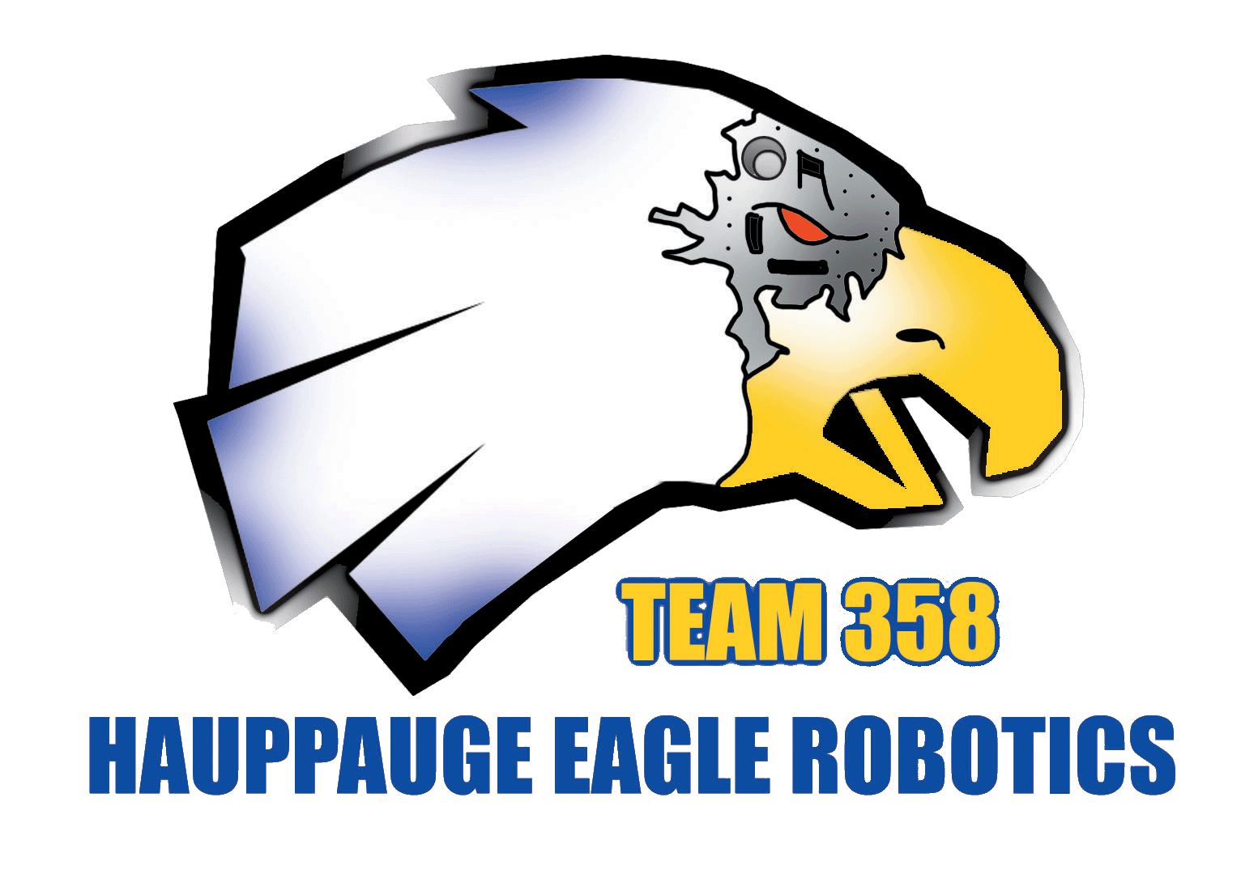
Robot Capabilities:
- x/y Crab Drive
- Speed: 8 feet per second
- Killer Autonomous
  - Takes down all ramp boxes vis multiple lunges
  - Script-driven for fast/reliable changes on the fly between matches.
  - x/y crab drivetrain means easy x/y autonomous
  - Click and drag autonomous coding system
- Arm lockdown on the ramp.

Physical Details:
- Low profile – slides under bar
- Crab drive – dual nested drivetrains (2nd- year of design)
  - 6” pneumatic wheels for greater holding power
  - 4 motor drive - 2 CIM & 2 Drill
  - Fast pneumatic drive change
- 6’ arm span to push boxes or grab boxes to stack
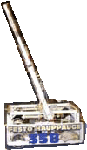
Control System:
- 2 Position Field Start Selection
- 8 pre-loaded Autonomous Programs
  - Script Driven Autonomous for Rapid risk-free changes
- Banner sensor encoders for distance feedback

Additional Info:
- 2002 same-design robot for driver practice
- 4 year veteran award winning team
- SBPLI Regional #1 undefeated seed
- BAE Regional #5 seed
- Longest winning streak in the nation

